

User Manual
DCM Compare Tool 2.8.6

A DVTk based tool

Document version 1.0
January 04, 2007

Table of Contents

1 Introduction 3
1.1 Revision History 3
1.2 General 3
1.3 System Requirements 3
1.3.1 Operating system 3
1.3.2 Software requirements 3
2 Software installation 4
2.1 Installation of DCM Compare software 4
3 Comparing DICOM Files 4
3.1 File comparison without filter. 5
3.2 File comparison with filter. 7

Introduction

Revision History
Version | Date | Description
1.0 | January 04, 2006 | First version of this document, describing the functionality of version 2.8.6.

General

The DCM Compare application is used to check the data consistency when DICOM data is transferred between different DICOM applications.
It compares two DCM files by
  - Comparing available attributes.
  - Comparing attribute values.
  - Comparing pixel data.

System Requirements

Operating system
The following operating systems are supported:
- Windows NT 4 SP6a
- Windows 2000 Professional
- Windows XP Professional

Software requirements
The following packages are required the installation of the software packages:

- Microsoft .NET framework 1.1

The Microsoft .NET framework software package is included in the installer of the DCM Compare Tool.

See: http://www.dvtk.org for new versions and features.

Software installation

All the steps of the installation process are controlled by the DCM Compare tool installer package. During the installation process, the installer will check if the Microsoft .NET Framework R1.1 is already installed on the system. If present, this step of the installation process will be skipped.

Installation of DCM Compare software

Download or copy the file DCM Compare.zip to a temp directory on the PC.
Double click (left mouse button) on the DCM Compare.zip and extract the file
DCM Compare.exe to the temp directory.
Start the installation procedure by double clicking with the left mouse button on the file DCM Compare.exe.
In the window “ Microsoft .NET Framework 1.1 setup” select “ I agree” to accept the license agreement. Press “install” to start the installation process. At the end of the installation procedure press “OK”
The Microsoft .NET Framework R1.1 software is installed.

After the .NET Framework software is installed, the installer package continues with the installation of the DCM Compare software.
Follow the instructions in the installer window and accept the license agreement.
After the button “install” is pressed, the installation will start. At the end, press the “Finish “ button. The DCM Compare package is installed.

In windows “All programs” there is an entry created “DVTK”. When selecting DVTK, a submenu with all installed DVTK applications will be opened. From this submenu the DCM Compare tool can be started. There is also a shortcut created on the desktop.

Comparing DICOM Files

In the screen capture below, the User Interface of the DCM Compare tool is displayed.

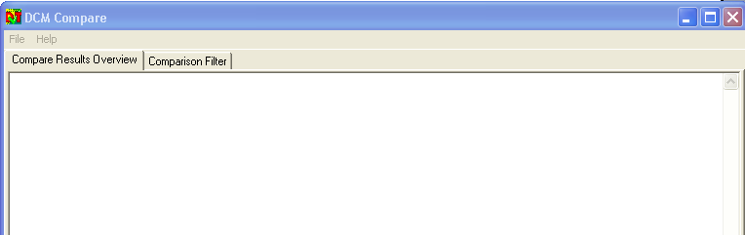

To start the file comparison, select “compare” from the File menu.
A choice can be made to start a comparison with or without using a filter.

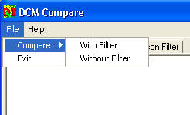

File comparison without filter.

Select from the File menu “Compare” and select “without filter” from the sub-menu.

In the “select first DCM File” window, select the first file. (This can be for example the DICOM file before it was stored into a PACS system).
In the “select second DCM File” window, select the second file. (This can be for example the DICOM file after it was retrieved from a PACS system).

After the file selection, the DCM Compare tool starts to compare both files. This can take a few seconds.
During the comparison, the tool checks for:
- Presence of attributes
- Differences in attribute values
- Differences in pixel data

The results window is divided in 2 parts, the left part shows the DICOM Header of the first selected DCM file, the right part shows the DICOM header of the second selected file. The DCM file names are listed on top of each section.

Example:

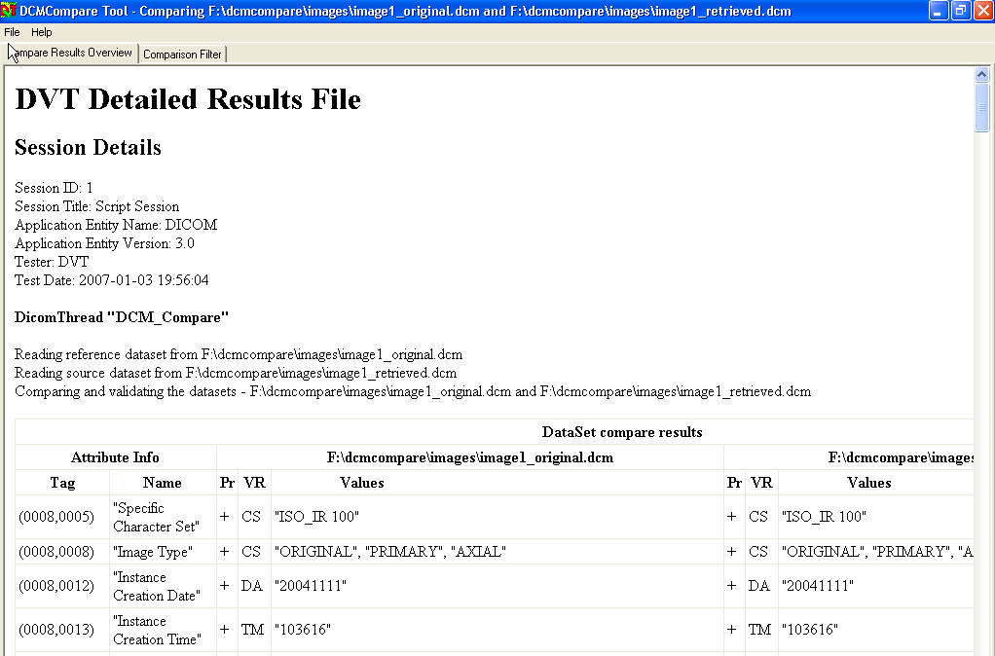

Any difference in the presence of attributes or attribute values will be marked as red in the results list by the application.

Example:

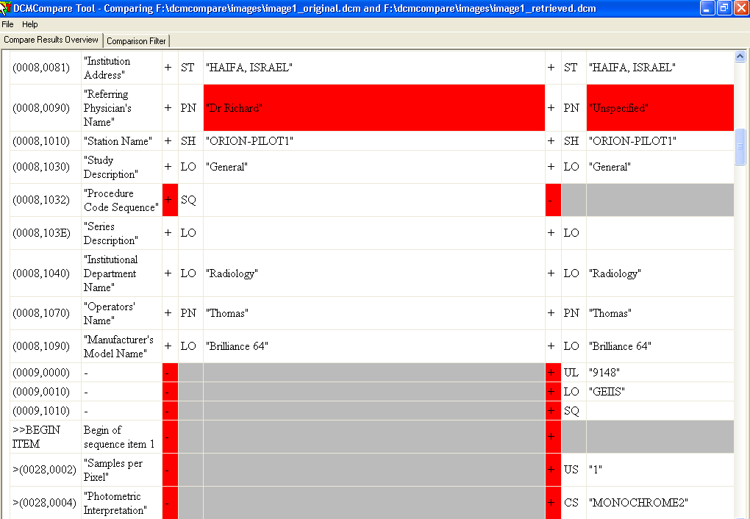

In the example above, the value of the attribute (0008,0090) Referring Physician’s Name has different values in the selected DCM files.

The attribute (0008,1032) “Procedure Code Sequence” is marked with a “ + “ in the left part, and marked as a “ – “ in the right part. This means that this attribute is present in the first selected DCM file but not present in the second selected DCM file.

The private attribute (0009,0000) is not present in the first select DCM file (marked with “ – “ ) , but is present in the second selected DCM file (marked with “ + “).

Remark:
When clicking with the right mouse button on a row in the results table, a pop-up menu appears from where the “copy” function can be selected. Via the copy function parts from the results list can be copied into any other document.

File comparison with filter.

Via the compare with filter function, it is possible to exclude attributes from the comparison results list.
The list of attributes for the filter can be composed in the DCM Compare tool UI by pressing on the “Comparison Filter” button.

The filter attribute list window appears.

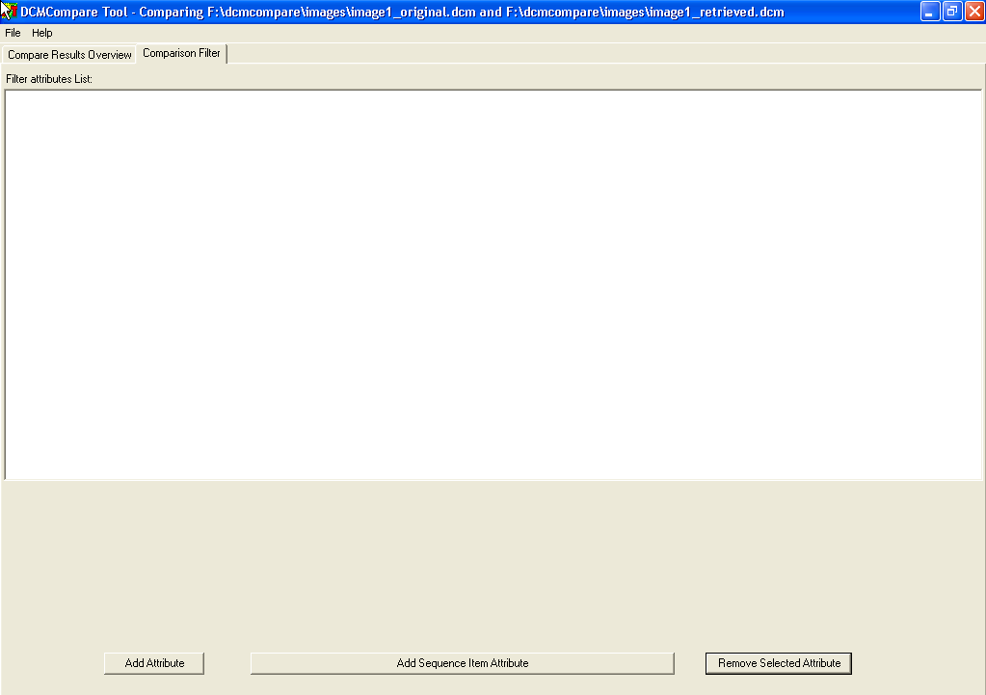

By pressing the “Add Attribute” button at the left bottom of the screen, the “Add attribute to the filter” window appears.

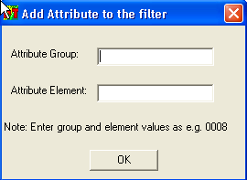

Enter the DICOM Group number (4 digits) and the DICOM Element number (4 digits). After pressing the OK button, the entered attribute will be added to the filter list.

Example:

Add attribute Refering Physician’s name (0008,0090) to the comparison filter:

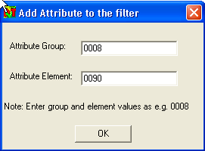

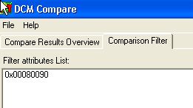

Multiple attributes can be added to the filter list.

With the button “Remove Selected Attribute”, attributes can be removed from the filter list.

Via the “Add Sequence Item Attribute” also sequence items can be added to the filter list.

Example: add to the filter attribute 0028,0002 of the first sequence item of sequence 0009,1010.

This has to be entered in the following way:
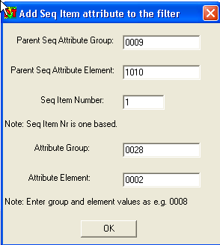
This results in the following filter list:

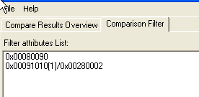

In case a new comparison is made on the selected DCM files, the attribute 0008,0090 and the sequence attribute 0009,1010 > 0028,0002 will be excluded from the comparison result.
Selecting the “Compare Again” function from the file menu can start a new comparison. In this way, it is not required to select the DCM files again.
When selecting the same files as used in the example in chapter 3.1, the “compare again with filter” function will give the following result:

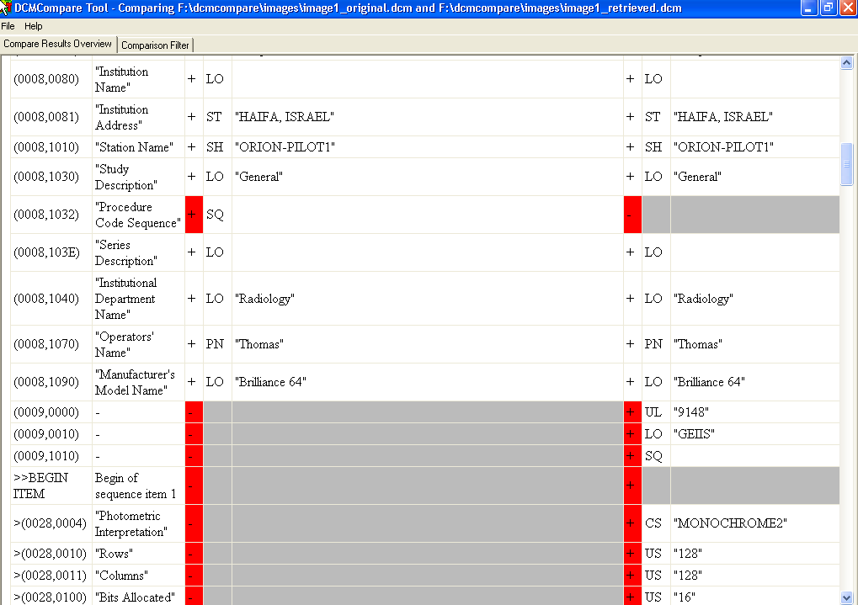

As a result of the created comparison filter, the attributes 0008,0090 and 0009,1010 > 0028,0020 are not listed in the results list.

Use the function “Compare, with Filter “ from the file menu in case a comparison has to be made on a new set of DCM files.

Remark:

- When an incorrect value is entered in the “Add Attribute to the Filter” or “Add Seq Item Attribute to the filter” window, the system responds with the message:

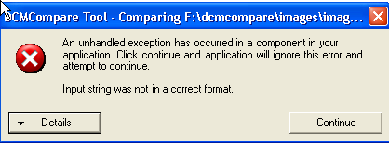

Press “continue” to proceed.

- The composed comparison filter is automatically saved by the application into the file C:\Program Files\DVTk\DCM Compare\ FilteredAttributes.txt.
Each time the DCM Compare application is started, the contents of this file is used as filter.

